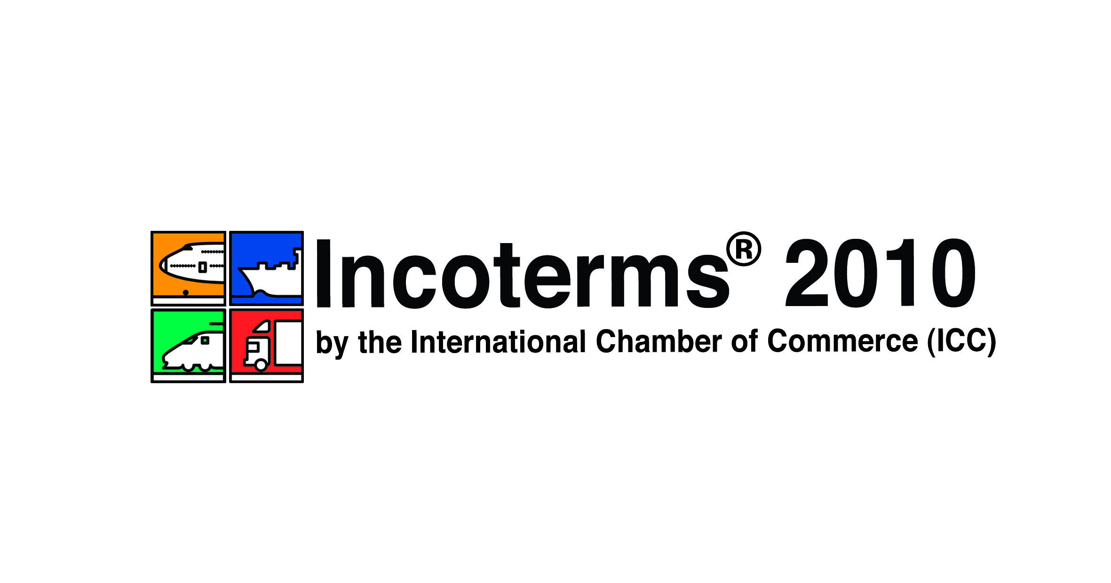 08/11
Publ.nr. | Tittel ICC PUBLIKASJONER | 2011  pris kr. | Informasjon
INTERNATIONAL TRADE
623 | A to Z of International Trade | 750
685 | Guide to Export-Import Basics | 930
691 | International Commercial Transactions, 3rd edition | 1.590
965 | International Commercial Law | 1.930
670 | International Certificate of Origin Guidelines | 510
695 | We Must Talk Because We Can | 750
958 | Treaties and International documents used in int. Trade Law | 1.545
648 | Preventing Financial Instrument Fraud | 1.127
INCOTERMS
715 | Incoterms 2010 på engelsk | 640
715 no | Incoterms 2010 på norsk |  | Ca. sept. 2011
720 | ICC Guide to Incoterms 2010 | 840
716 | Incoterms 2010 Wallchart (10-pack) engelsk | 905
716 | Incoterms 2010 Wallchart (1 stk) | 115
MODEL COMMERCIAL CONTRACTS (alle Modellkontrakter er inkl. CD-Rom)
650 | ICC Force Majeure and Hardship Clauses | 250
671 | Drafting and Negotiating International Commercial Contracts | 2.047
644 | ICC Model Commercial Agency Contract | 971
653 | ICC Model Contract Turnkey Supply of an Industrial Plant | 971
646 | ICC Model Distributorship Contract, 2nd Edition | 971
556 | ICC Model International Sale Contract | 971
656 | ICC Model Mergers & Acquisitions Contract I | 971
619 | ICC Model Occasional Intermediary Contract | 971
657 | ICC Model Selective Distributorship Contract | 971
659 | ICC Model Turnkey Contract for Major Projects | 971
673 | ICC Model International Trademark Licence | 971
674 | ICC Model International Transfer of Technology Contract | 971
664 | ICC Model Confidentiality Agreement | 515
INTERNATIONAL BANKING
967 | Annual Survey of Letter of Credit Law and Practise | 2.150
551 | ICC Uniform Rules for Bank to Bank Reimb. – a Commentary | 292
681 | International Standard Banking Practice (ISBP) | 390
590 | International Standby Practices (ISP98) | 270
600 | UCP 600 – Documentary Credits | 300
600/no | Rembursregler eng./no. | 300
600 LF | UCP 600 Leaflet (pack of 25) | 900
680 | Commentary on UCP 600 | 770
658 | Leading Court Cases on Letters of Credit | 775
682 | Insights into UCP 600 | 877
683 | The Complete UCP 600 | 877
694 | User’s Handbook for Documentary Credits under UCP 600 | 830
758 | ICC Uniform Rules for Demand Guarantees (URDG) | 350
702 | Guide to ICC Uniform Rules for Demand Guarantees | 1.475
697 | ICC Banking Commission Opinions 2005-2008 | 971
522 | ICC Uniform Rules for Collections | 270
503 | ICC Model Forms for Issuing Demand Guarantees | 275
325 | ICC Uniform Rules for Contract Guarantees | 250
LAW & ARBITRATION
971 | 2011 Annual Review of International Banking Law & Practice | 1.070
728 | Decisions on ICC Arbitration Procedure | 971
701 | Multiparty Arbitration | 971
698 | Written Evidence and Discovery in International Arbitration | 1.600
961 | A Guide to the ICC Rules of Arbitration | 2.100
672 | Business Law in China
965 | International Commercial Law Source Materials | 1.930
690 | Independence of Arbitrators | 971
663 | ICC Legal Handbook on Global Sourcing Contracts | 770
963 | ADR in Business | 1.730
668 | Evaluation of Damages in International Arbitration | 971
651 | Arbitration – Money Laundering, Corruption and Fraud | 645
689 | Arbitration and Oral Evidence | 680
959 | ICC Arbitration in Practice | 1.590
688 | Complex Arbitrations | 612
936 | Handbook of ICC Arbitration | 2.545
846 | ICC Rules of Arbitration | 50
598 | Improving International Arbitration | 850
609 | International Commercial Arbitration in Asia | 530
692 | Parallel State and Arbitral Procedures | 940
564 | The Status of the Arbitrator | 430
 | ICC MEDLEMMER FÅR 20 % RABATT

ICC Norge
P.O.Box 2626 Solli, 0203 Oslo
Besøksadresse: Henrik Ibsensgate 100, Oslo
Tel. 22561688 / Mob. 90039070 / Fax. 22555711
Internet: www.iccnorge.no
E-mail: lisbeth@iccnorge.no

